

**SAMAR STATE UNIVERSITY**

Arteche Blvd., Catbalogan City, Philippines 67000

**College of Engineering**

**"Vibration Analysis of Motorcycle Gear Shifts Using Piezoelectric Sensors"**

Engr. Rojay A. Flores

**Subject Teacher**

Dacles, Dominador Jr. P.

Bernas, Christopher Jr. A.

Faith, Mariella T.

1. **INTRODUCTION**

Gear transitions in motorcycles generate distinct vibration patterns that can provide insights into mechanical performance, efficiency, and potential wear in the transmission system. As the gear shifts from neutral to higher gears, changes in vibration frequency, amplitude, and spectral distribution occur due to variations in engine load and mechanical engagement. Analyzing these vibrations can help in understanding how different gear positions influence the overall system behavior.

This case study examines the vibration characteristics of a stationary manual motorcycle across Neutral, Gear 1, Gear 2, Gear 3, and Gear 4. By capturing and analyzing waveform and frequency spectra, the study aims to identify significant differences in vibration intensity and frequency distribution at each gear position. The results provide valuable information for detecting abnormalities, improving mechanical efficiency, and potentially applying predictive maintenance strategies in motorcycle transmission systems.

1. **MATERIALS**

* 1 piezoelectric sensor
* 1 Megaohms resistor
* Analog discovery 3
* Manual motorcycles (Suzuki Raider 110)
* Arduino uno

**III. PROCEDURE**

1. Motorcycle Setup

* The motorcycle is placed in a stationary position on a stable surface to eliminate movement-related variables.
* The engine starts in Neutral before shifting through the other gears.
* Vibrations from the engine and transmission system are recorded for each gear level.

2. Piezoelectric Sensor Setup

* In this study, only one piezoelectric sensor is used to capture the desired vibration output.
* The sensor is placed near the engine to ensure optimal data collection and accurately detect vibrations from gear transitions.
* The mounting surface is carefully selected to minimize external noise and ensure that the sensor picks up vibrations directly from the engine and transmission system.

3. Data Collection

* All vibration data collected from the motorcycle engine is recorded using waveform analysis software for analyzation and interpretation.
* The motorcycle is maintained at a consistent engine speed (RPM) while data is recorded to ensure uniformity across all gear states.
* The vibrations are monitored for Neutral, Gear 1, Gear 2, Gear 3, and Gear 4, ensuring sufficient time is given in each gear for accurate data acquisition.
* The data is collected in the form of waveforms and frequency spectra to analyze variations in vibration intensity and distribution.
* For each gear transition, at least two samples were collected to accurately capture the waveform.

4. Signal Processing & Spectrum Analysis

* The recorded vibration data is processed to extract waveform patterns, frequency peaks, and amplitude variations.
* The Fast Fourier Transform (FFT) method is used to convert waveform signals into frequency spectra for analysis.
* The dominant frequency components and noise levels are identified for each gear position.

5. Data Comparison & Interpretation

The waveforms and frequency spectra of all gear positions are compared to determine:

* Changes in frequency distribution as gears shift.
* Variations in vibration intensity across different gear states.
* Noise levels and mechanical stress indicators in each gear.
* A comparative table is created to highlight the key differences between gear states.

1. **RESULTS**

**Piezoelectric sensor in Oscilloscope**

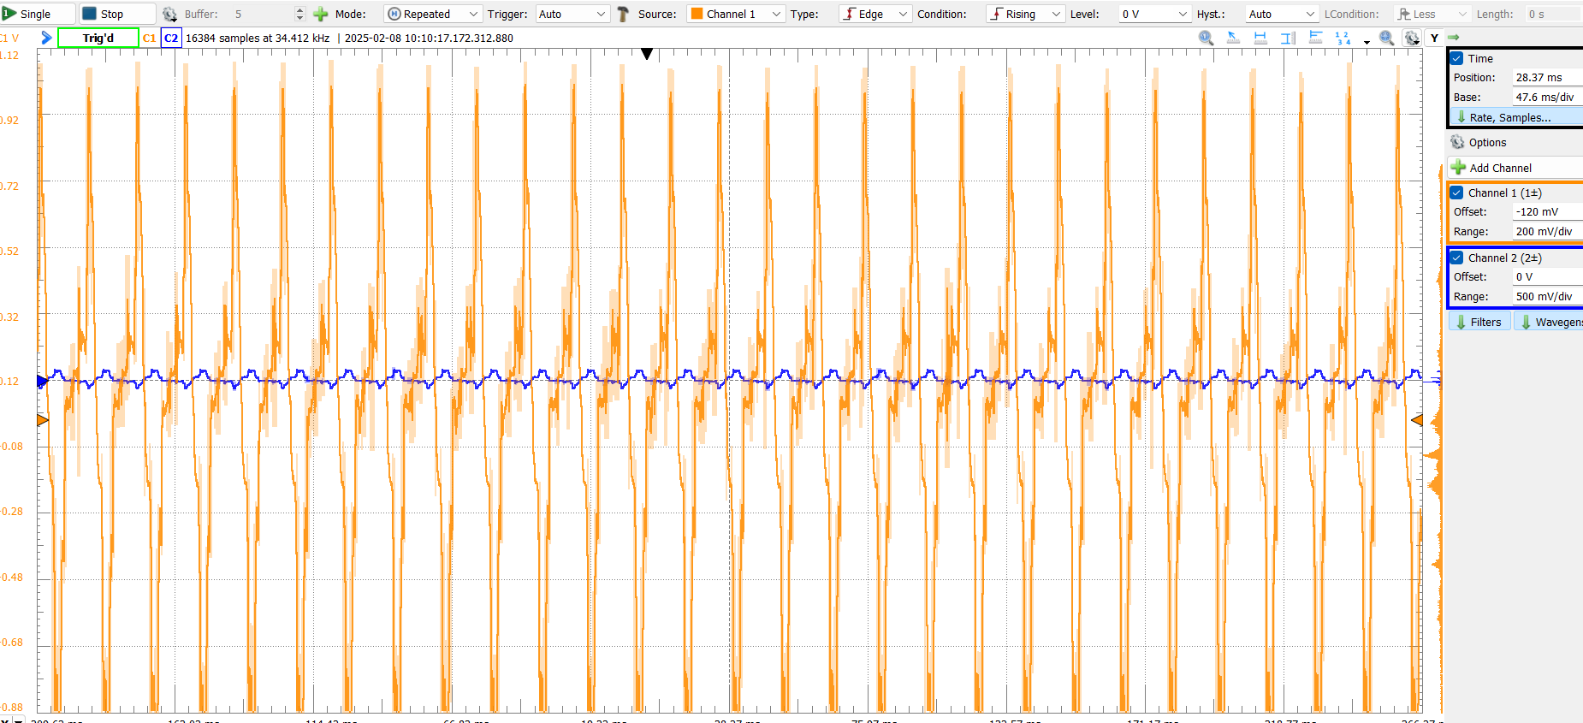 Neutral sample 1

Neutral Sample 2

**Gear 1 sample 1**

**Gear 1 sample 2**

Gear 2 sample 1

Gear 2 sample 2

Gear 3 sample 1

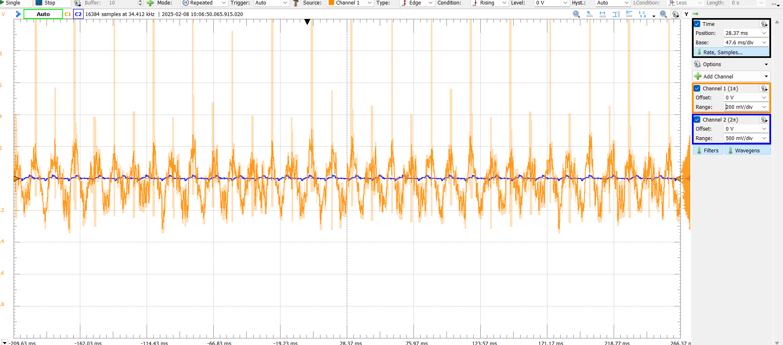

Gear 3 sample 2

Gear 4 sample 1

Gear 4 sample 2

Here’s a comparative table based on the waveform that focuses on Amplitude, Frequency Content, Noise Levels, and Pattern Consistency across different gear levels.

|  |  |  |  |  |  |
| --- | --- | --- | --- | --- | --- |
| Feature | Neutral | Gear 1 | Gear 2 | Gear 3 | Gear 4 |
| Amplitude (voltage range) | Low, stable | Slight increase, minor peaks | Moderate increase, more variations | Higher peaks, more fluctuation | Highest amplitude, significant peaks |
| Frequency content | Low-frequency, smooth waveform | Slight increase in frequency | Noticeable increase in frequency | High frequency with more oscillations | Highest frequency, dense oscillations |
| Noise levels | Minimal noise, clean waveform | Slight background noise | Moderate noise, slight irregularities | Higher noise, less stable | Most noise, chaotic waveform |
| Pattern consistency | Highly stable, periodic | Mostly stable, minor deviations | Less stable, moderate variations | Irregular, frequent shifts | Most irregular, chaotic waveform |

As the gear level increases, both amplitude and frequency rise significantly, resulting in more dynamic waveforms. Higher gears introduce increased noise levels, leading to more chaotic and irregular waveforms. While Neutral and Gear 1 exhibit relatively stable patterns, Gear 4 displays the highest amplitude and frequency, making it the most chaotic among all gear transitions.

Piezoelectric Sensor in Spectrum

Neutral sample 1

Neutral sample 2

Gear 1 sample 1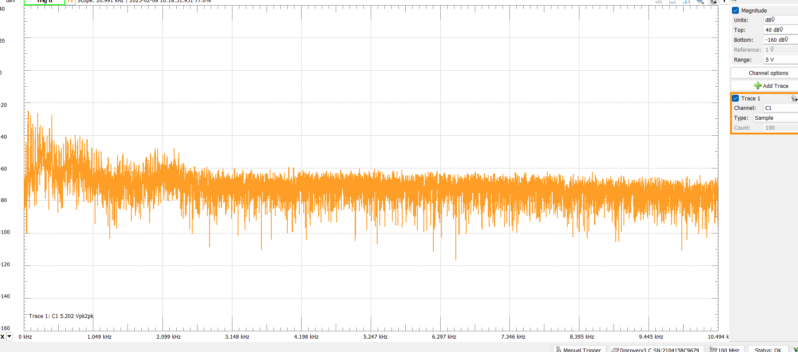

Gear 1 sample 2

Gear 2 sample 1

Gear 2 sample 2

Gear 3 sample 1

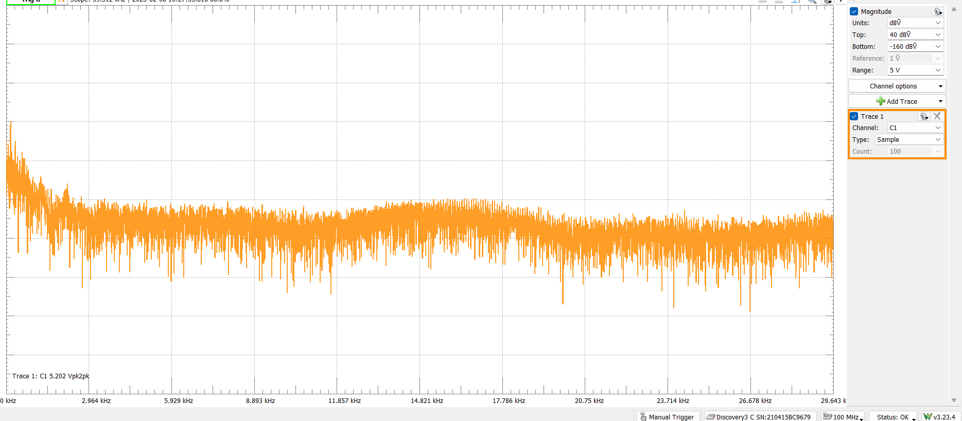

Gear 3 sample 2

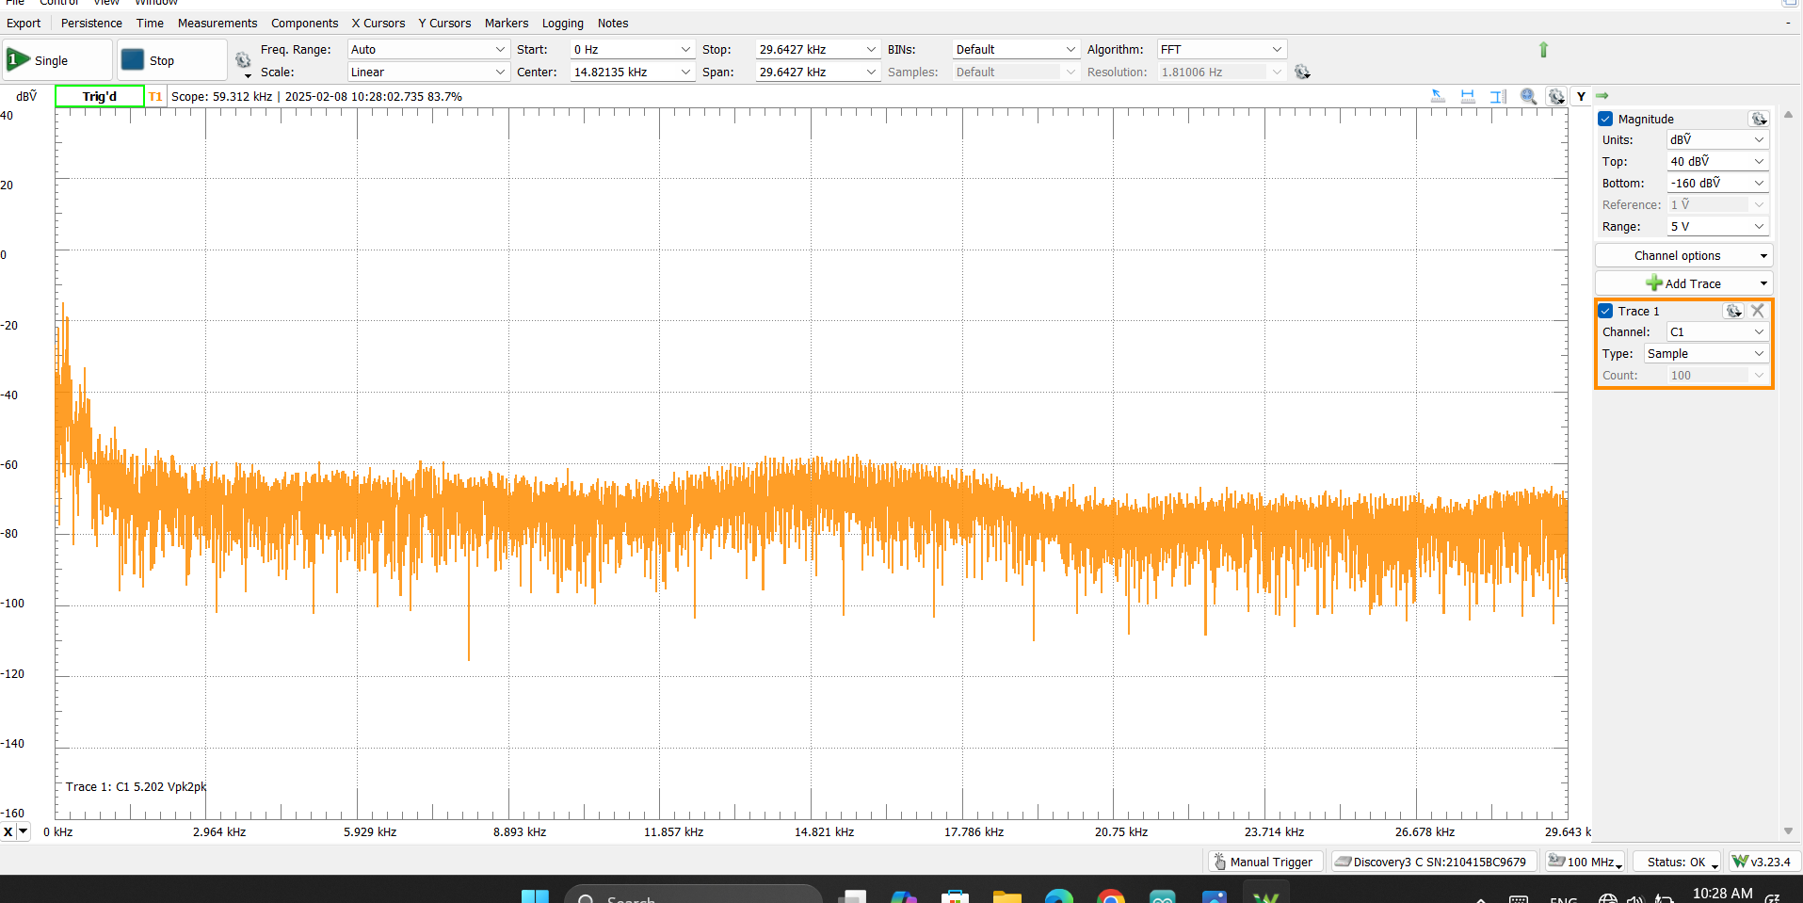

Gear 4 sample 1

Gear 4 sample 2

Comparison Table of Output Spectrum Waveforms

|  |  |  |  |  |  |  |  |
| --- | --- | --- | --- | --- | --- | --- | --- |
| Feature | Neutral | Gear 1 | | Gear 2 | Gear 3 | | Gear 4 |
| Frequency Characteristics | Highest frequency among all gears | Frequency slightly lower than Neutral | | Frequency decreases further | Frequency reduces, but amplitude rises significantly | | but highest amplitude |
| Amplitude Characteristics | Moderate amplitude with consistent pattern | Amplitude increases slightly | | Amplitude continues to increase | Higher amplitude with irregular fluctuations | | Most irregular and chaotic waveform |
| Waveform Structure | Well-structured and stable waveform | More structured waveform but with minor variations | | Less structured than Neutral and Gear 1 | Less structured, more chaotic waveform | | Very unstable structure |
| Noise Levels | Low noise level | Slight increase in noise | | Noticeable noise level increase | High noise level | | Highest noise level observed |
| Dominant frequency | 0 - 5 kHz | | 0 - 10 kHz | 5 - 15 kHz | | 10 - 20 kHz | 15- 25 kHz |

1. **CONCLUSION**

This study explored how a motorcycle’s vibrations change as it shifts through different gears, using a piezoelectric sensor to capture and analyze the data. The results clearly show that each gear transition affects the frequency, amplitude, and overall structure of the vibrations.

In Neutral, the vibrations were at their highest frequency and most stable, as there was no direct engagement with the transmission. However, as the gears increased, the frequency gradually decreased while the amplitude and noise levels grew stronger. This change happens because higher gears introduce more mechanical load, gear meshing, and overall drivetrain movement, which disrupt the smoothness of the vibrations.

By Gear 4, the vibrations became more intense and chaotic, with the highest amplitude and a shift toward higher-frequency noise. This suggests that at higher gears, the engine and transmission experience more stress, leading to greater energy transfer and more irregular movement patterns.

Overall, this study highlights how gear transitions significantly impact a motorcycle’s vibration behavior. Understanding these patterns can be valuable for engine diagnostics, performance tuning, and even predicting potential mechanical issues. Future research could expand on this by analyzing vibrations in real riding conditions to get a more complete picture of how these effects play out on the road.